**DAY 3 - Sample Selenium TestNG Script Execution And Sample Selenium Grid Setup And Execution Assignment**

1. TestNG Installation and Sample Script Execution

Installing TestNG Plugin for Eclipse

**Step 1** − Launch Eclipse and select 'Install New Software'.

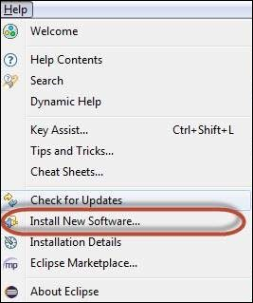

**Step 2** − Enter the URL as 'http://beust.com/eclipse' and click 'Add'.

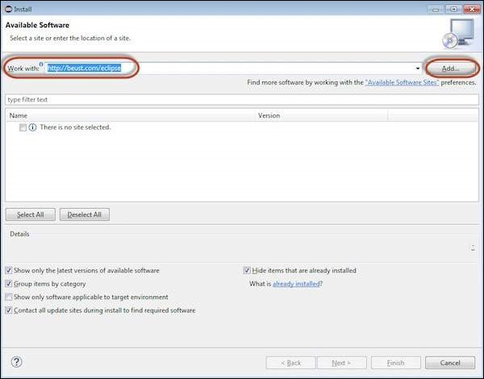

**Step 3** − The dialog box 'Add Repository' opens. Enter the name as 'TestNG' and click 'OK'

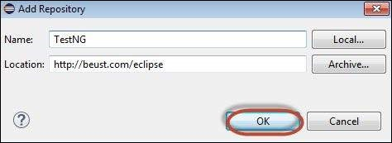

**Step 4** − Click 'Select All' and 'TestNG' would be selected as shown in the figure.

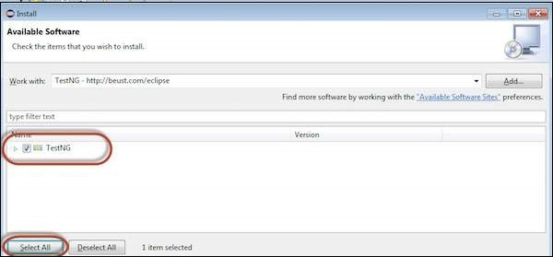

**Step 5** − Click 'Next' to continue.

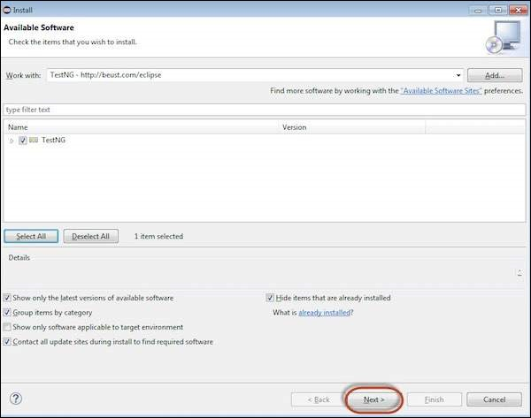

**Step 6** − Review the items that are selected and click 'Next'.

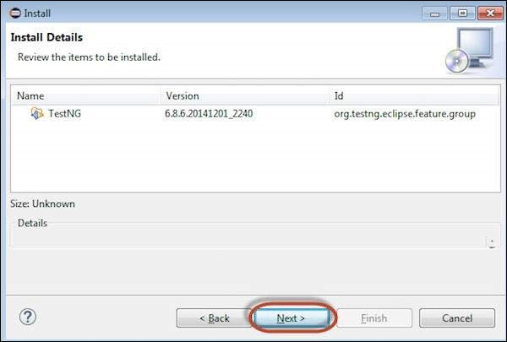

**Step 7** − "Accept the License Agreement" and click 'Finish'.

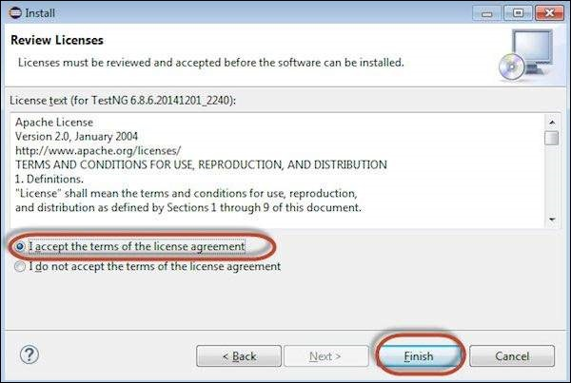

**Step 8** − TestNG starts installing and the progress would be shown follows.

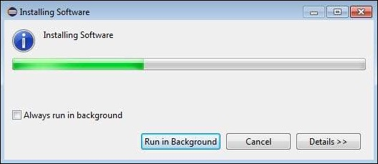

**Step 9** − Security Warning pops up as the validity of the software cannot be established. Click 'Ok'.

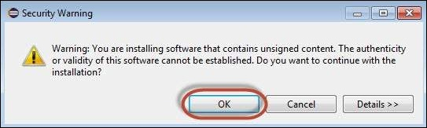

**Step 10** − The Installer prompts to restart Eclipse for the changes to take effect. Click 'Yes'.

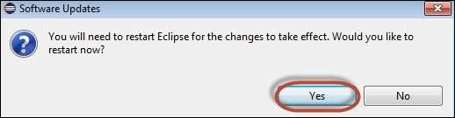

TestNG-Eclipse Project Setup

**Step 1** − Launch Eclipse and create a 'New Java Project' as shown below.

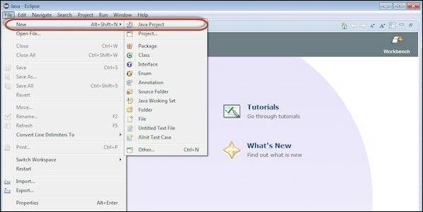

**Step 2** − Enter the project name and click 'Next'.

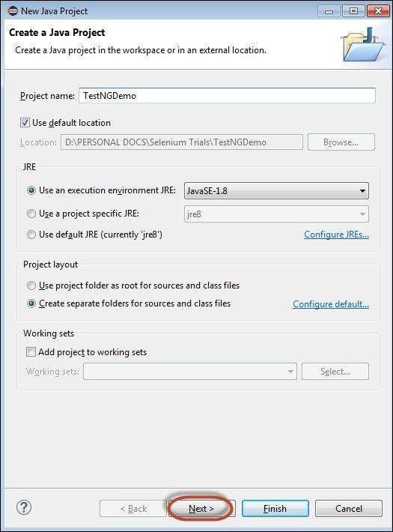

**Step 3** − Navigate to "Libraries" Tab and Add the Selenium Remote Control Server JAR file by clicking on "Add External JAR's" as shown below.

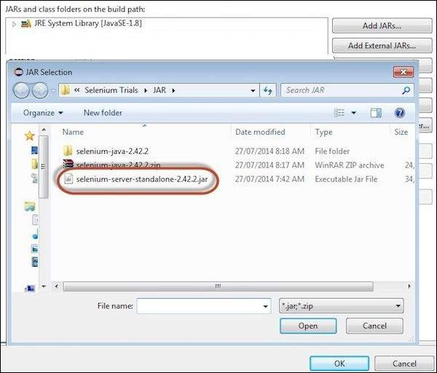

**Step 4** − The added JAR file is shown here. Click 'Add Library'.

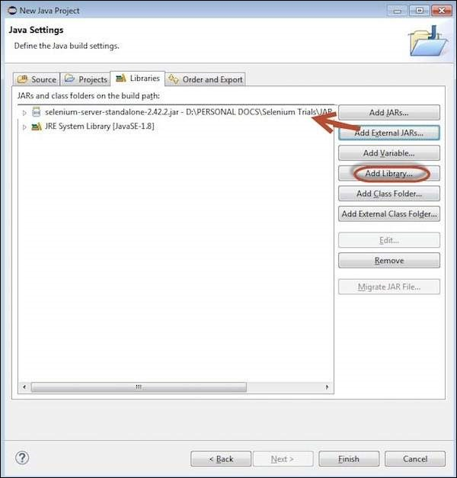

**Step 5** − The 'Add Library' dialog opens. Select 'TestNG' and click 'Next' in the 'Add Library' dialog box.

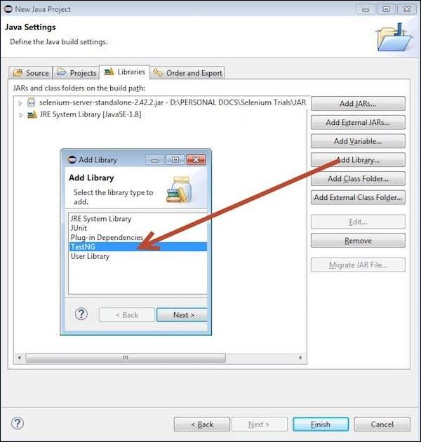

**Step 6** − The added 'TestNG' Library is added and it is displayed as shown below.

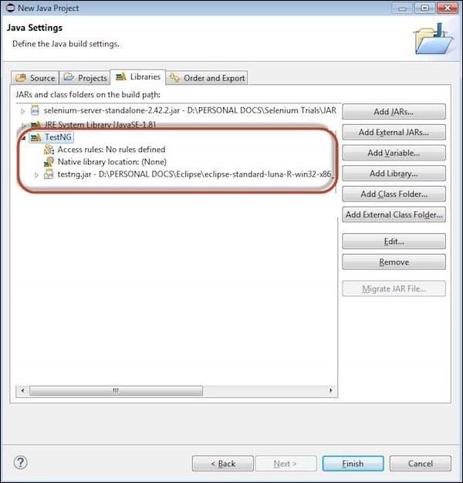

**Step 7** − Upon creating the project, the structure of the project would be as shown below.

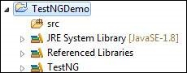

**Step 8** − Right-click on 'src' folder and select New >> Other.

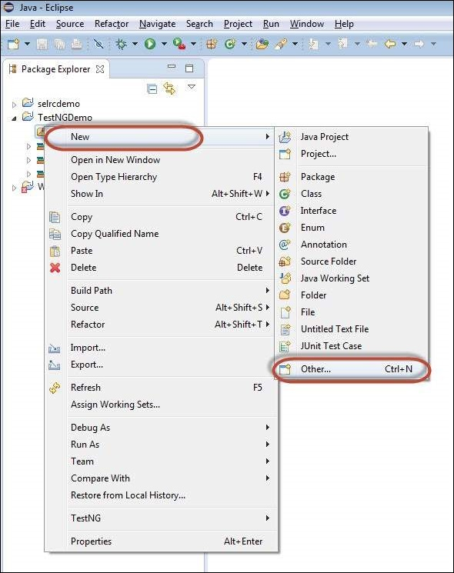

**Step 9** − Select 'TestNG' and click 'Next'.

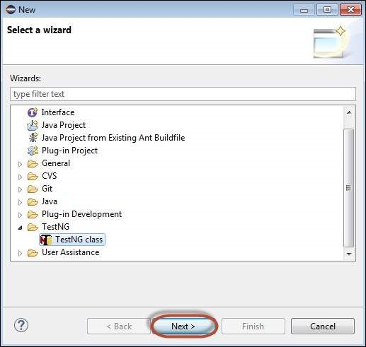

**Step 10** − Select the 'Source Folder' name and click 'Ok'.

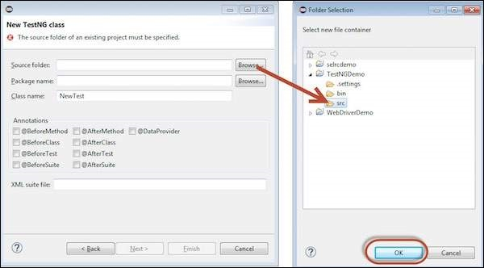

**Step 11** − Select the 'Package name', the 'class name', and click 'Finish'.

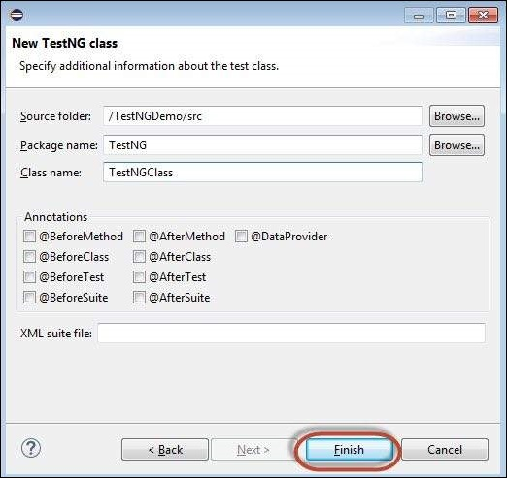

**Step 12** − The Package explorer and the created class would be displayed.

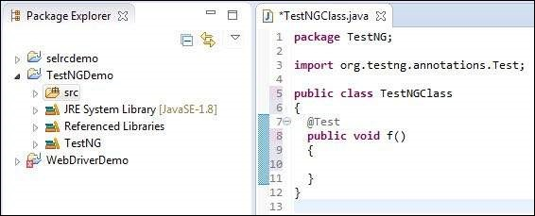

First Test in TestNG

Now let us start scripting using TestNG. Let us script for the same example that we used for understanding the WebDriver. We will use the demo application, [www.calculator.net](https://www.calculator.net/), and perform percent calculator.

*In the following test, you will notice that there is NO main method, as testNG will drive the program execution flow. After initializing the driver, it will execute the '@BeforeTest' method followed by '@Test' and then '@AfterTest'. Please note that there can be any number of '@Test' annotation in a class but '@BeforeTest' and '@AfterTest' can appear only once.*

package TestNG;

import java.util.concurrent.TimeUnit;

import org.openqa.selenium.*;

import org.openqa.selenium.firefox.FirefoxDriver;

import org.testng.annotations.AfterTest;

import org.testng.annotations.BeforeTest;

import org.testng.annotations.Test;

public class TestNGClass {

WebDriver driver = new FirefoxDriver();

@BeforeTest

public void launchapp() {

// Puts an Implicit wait, Will wait for 10 seconds before throwing exception

driver.manage().timeouts().implicitlyWait(10, TimeUnit.SECONDS);

// Launch website

driver.navigate().to("http://www.calculator.net");

driver.manage().window().maximize();

}

@Test

public void calculatepercent() {

// Click on Math Calculators

driver.findElement(By.xpath(".//*[@id='menu']/div[3]/a")).click();

// Click on Percent Calculators

driver.findElement(By.xpath(".//*[@id='menu']/div[4]/div[3]/a")).click();

// Enter value 10 in the first number of the percent Calculator

driver.findElement(By.id("cpar1")).sendKeys("10");

// Enter value 50 in the second number of the percent Calculator

driver.findElement(By.id("cpar2")).sendKeys("50");

// Click Calculate Button

driver.findElement(By.xpath(".//*[@id='content']/table/tbody/tr/td[2]/input")).click();

// Get the Result Text based on its xpath

String result =

driver.findElement(By.xpath(".//*[@id='content']/p[2]/span/font/b")).getText();

// Print a Log In message to the screen

System.out.println(" The Result is " + result);

if(result.equals("5")) {

System.out.println(" The Result is Pass");

} else {

System.out.println(" The Result is Fail");

}

}

@AfterTest

public void terminatetest() {

driver.close();

}

}

Execution

To execute, right click on the created XML and select "Run As" >> "TestNG Suite"

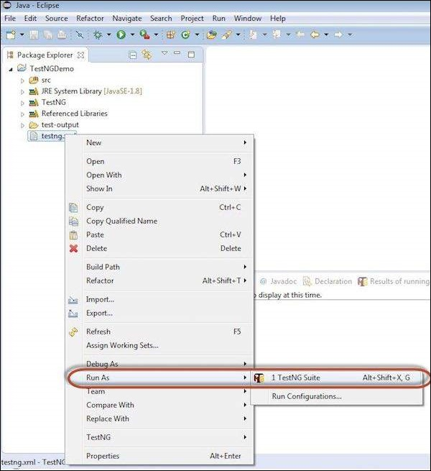

Result Analysis

The output is thrown to the console and it would appear as shown below. The console output also has an execution summary.

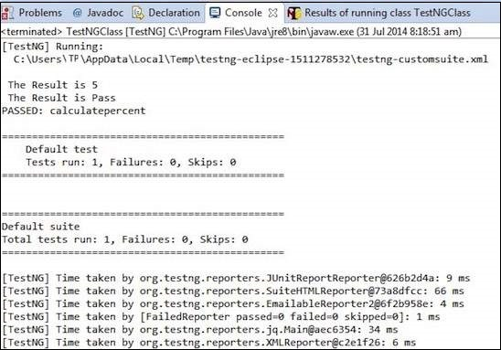

The result of TestNG can also be seen in a different tab. Click on 'HTML Report View' button as shown below.

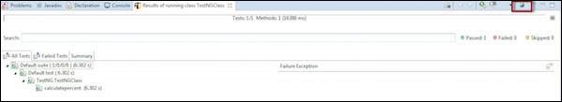

The HTML result would be displayed as shown below.

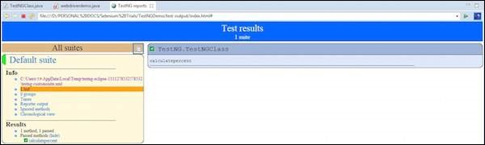

2. Selenium – Grid Setup and Sample Execution

In order to work with the Grid, we need to follow certain protocols. Listen below are the major steps involved in this process −

* Configuring the Hub
* Configuring the Nodes
* Develop the Script and Prepare the XML File
* Test Execution
* Result Analysis

Let us discuss each of these steps in detail.

Configuring the Hub

**Step 1** − Download the latest Selenium Server standalone JAR file from <http://docs.seleniumhq.org/download/>. Download it by clicking on the version as shown below.

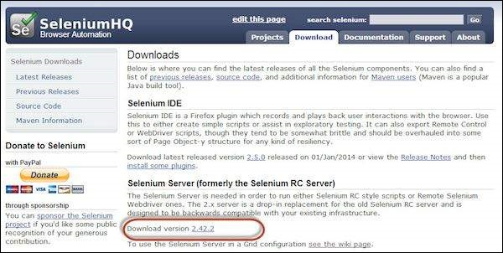

**Step 2** − Start the Hub by launching the Selenium Server using the following command. Now we will use the port '4444' to start the hub.

**Note** − Ensure that there are no other applications that are running on port# 4444.

java -jar selenium-server-standalone-2.25.0.jar -port 4444 -role hub -nodeTimeout 1000

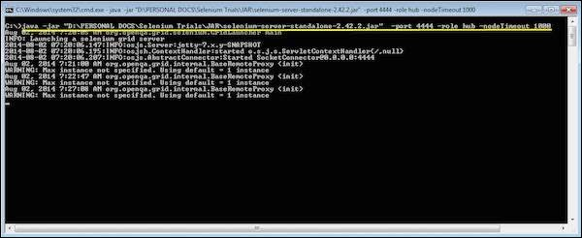

**Step 3** − Now open the browser and navigate to the URL http//localhost:4444 from the Hub (The system where you have executed Step#2).

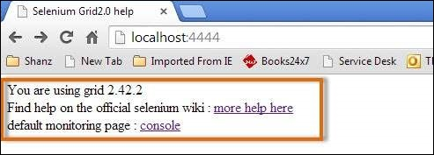

**Step 4** − Now click on the 'console' link and click 'view config'. The config of the hub would be displayed as follows. As of now, we haven't got any nodes, hence we will not be able to see the details.

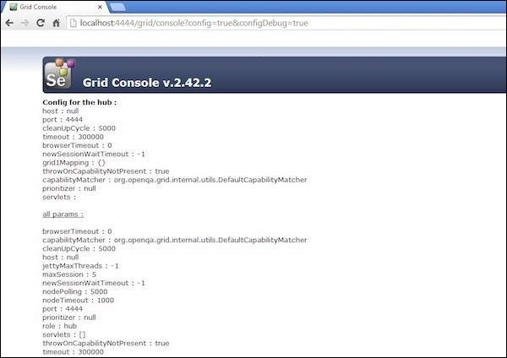

Configuring the Nodes

**Step 1** − Logon to the node (where you would like to execute the scripts) and place the 'selenium-server-standalone-2.42.2' in a folder. We need to point to the selenium-server-standalone JAR while launching the nodes.

**Step 2** − Launch FireFox Node using the following below command.

java -jar D:\JAR\selenium-server-standalone-2.42.2.jar

-role node -hub http://10.30.217.157:4444/grid/register

-browser browserName = firefox -port 5555

Where,

D:\JAR\selenium-server-standalone-2.42.2.jar = Location of the Selenium Server Standalone Jar File(on the Node Machine)

http://10.30.217.157:4444 = IP Address of the Hub and 4444 is the port of the Hub

browserName = firefox (Parameter to specify the Browser name on Nodes)

5555 = Port on which Firefox Node would be up and running.

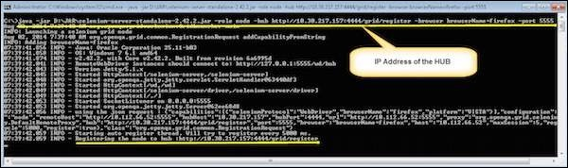

**Step 3** − After executing the command, come back to the Hub. Navigate to the URL - http://10.30.217.157:4444 and the Hub would now display the node attached to it.

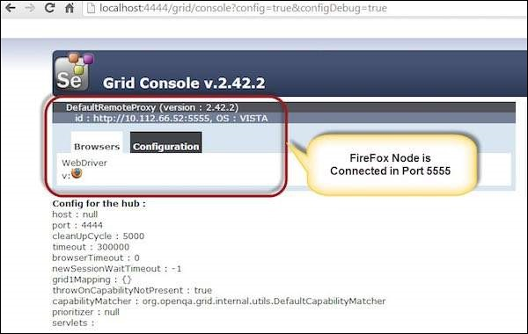

**Step 4** − Now let us launch the Internet Explorer Node. For launching the IE Node, we need to have the Internet Explorer driver downloaded on the node machine.

**Step 5** − To download the Internet Explorer driver, navigate to <http://docs.seleniumhq.org/download/> and download the appropriate file based on the architecture of your OS. After you have downloaded, unzip the exe file and place in it a folder which has to be referred while launching IE nodes.

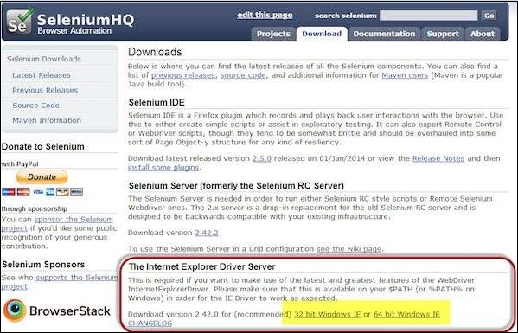

**Step 6** − Launch IE using the following command.

C:\>java -Dwebdriver.ie.driver = D:\IEDriverServer.exe

-jar D:\JAR\selenium-server-standalone-2.42.2.jar

-role webdriver -hub http://10.30.217.157:4444/grid/register

-browser browserName = ie,platform = WINDOWS -port 5558

Where,

D:\IEDriverServer.exe = The location of the downloaded the IE Driver(on the Node Machine)

D:\JAR\selenium-server-standalone-2.42.2.jar = Location of the Selenium Server Standalone Jar File(on the Node Machine)

http://10.30.217.157:4444 = IP Address of the Hub and 4444 is the port of the Hub

browserName = ie (Parameter to specify the Browser name on Nodes)

5558 = Port on which IE Node would be up and running.

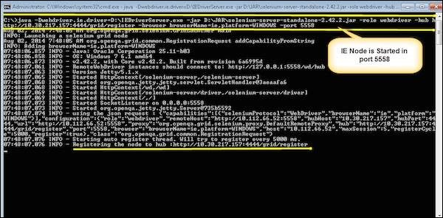

**Step 7** − After executing the command, come back to the Hub. Navigate to the URL - http://10.30.217.157:4444 and the Hub would now display the IE node attached to it.

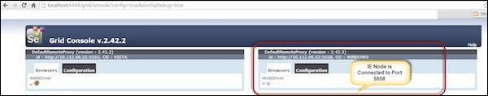

**Step 8** − Let us now launch Chrome Node. For launching the Chrome Node, we need to have the Chrome driver downloaded on the node machine.

**Step 9** − To download the Chrome Driver, navigate to <http://docs.seleniumhq.org/download/> and then navigate to Third Party Browser Drivers area and click on the version number '2.10' as shown below.

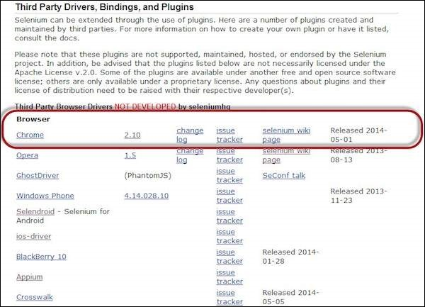

**Step 10** − Download the driver based on the type of your OS. We will execute it on Windows environment, hence we will download the Windows Chrome Driver. After you have downloaded, unzip the exe file and place it in a folder which has to be referred while launching chrome nodes.

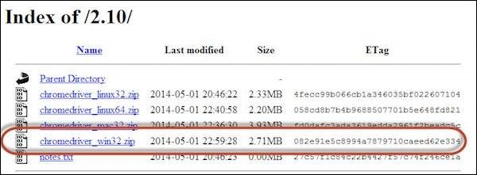

**Step 11** − Launch Chrome using the following command.

C:\>java -Dwebdriver.chrome.driver = D:\chromedriver.exe

-jar D:\JAR\selenium-server-standalone-2.42.2.jar

-role webdriver -hub http://10.30.217.157:4444/grid/register

-browser browserName = chrome, platform = WINDOWS -port 5557

Where,

D:\chromedriver.exe = The location of the downloaded the chrome Driver(on the Node Machine)

D:\JAR\selenium-server-standalone-2.42.2.jar = Location of the Selenium Server Standalone Jar File(on the Node Machine)

http://10.30.217.157:4444 = IP Address of the Hub and 4444 is the port of the Hub

browserName = chrome (Parameter to specify the Browser name on Nodes)

5557 = Port on which chrome Node would be up and running.

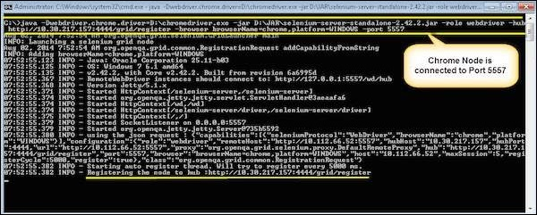

**Step 12** − After executing the command, come back to the Hub. Navigate to the URL - http://10.30.217.157:4444 and the Hub would now display the chrome node attached to it.

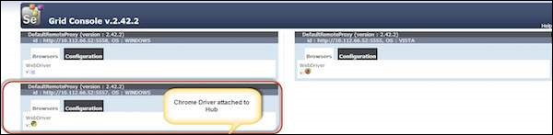

Develop the Script and Prepare the XML File

**Step 1** − We will develop a test using TestNG. In the following example, we will launch each one of those browsers using remote webDriver. It can pass on their capabilities to the driver so that the driver has all information to execute on Nodes.

The Browser Parameter would be passed from the "XML" file.

package TestNG;

import org.openqa.selenium.*;

import org.openqa.selenium.remote.RemoteWebDriver;

import org.openqa.selenium.remote.DesiredCapabilities;

import org.testng.annotations.AfterTest;

import org.testng.annotations.BeforeTest;

import org.testng.annotations.Parameters;

import org.testng.annotations.Test;

import java.net.URL;

import java.util.concurrent.TimeUnit;

import java.net.MalformedURLException;

public class TestNGClass {

public WebDriver driver;

public String URL, Node;

protected ThreadLocal<RemoteWebDriver> threadDriver = null;

@Parameters("browser")

@BeforeTest

public void launchapp(String browser) throws MalformedURLException {

String URL = "http://www.calculator.net";

if (browser.equalsIgnoreCase("firefox")) {

System.out.println(" Executing on FireFox");

String Node = "http://10.112.66.52:5555/wd/hub";

DesiredCapabilities cap = DesiredCapabilities.firefox();

cap.setBrowserName("firefox");

driver = new RemoteWebDriver(new URL(Node), cap);

// Puts an Implicit wait, Will wait for 10 seconds before throwing exception

driver.manage().timeouts().implicitlyWait(10, TimeUnit.SECONDS);

// Launch website

driver.navigate().to(URL);

driver.manage().window().maximize();

} else if (browser.equalsIgnoreCase("chrome")) {

System.out.println(" Executing on CHROME");

DesiredCapabilities cap = DesiredCapabilities.chrome();

cap.setBrowserName("chrome");

String Node = "http://10.112.66.52:5557/wd/hub";

driver = new RemoteWebDriver(new URL(Node), cap);

driver.manage().timeouts().implicitlyWait(10, TimeUnit.SECONDS);

// Launch website

driver.navigate().to(URL);

driver.manage().window().maximize();

} else if (browser.equalsIgnoreCase("ie")) {

System.out.println(" Executing on IE");

DesiredCapabilities cap = DesiredCapabilities.chrome();

cap.setBrowserName("ie");

String Node = "http://10.112.66.52:5558/wd/hub";

driver = new RemoteWebDriver(new URL(Node), cap);

driver.manage().timeouts().implicitlyWait(10, TimeUnit.SECONDS);

// Launch website

driver.navigate().to(URL);

driver.manage().window().maximize();

} else {

throw new IllegalArgumentException("The Browser Type is Undefined");

}

}

@Test

public void calculatepercent() {

// Click on Math Calculators

driver.findElement(By.xpath(".//*[@id = 'menu']/div[3]/a")).click();

// Click on Percent Calculators

driver.findElement(By.xpath(".//*[@id = 'menu']/div[4]/div[3]/a")).click();

// Enter value 10 in the first number of the percent Calculator

driver.findElement(By.id("cpar1")).sendKeys("10");

// Enter value 50 in the second number of the percent Calculator

driver.findElement(By.id("cpar2")).sendKeys("50");

// Click Calculate Button

// driver.findElement(By.xpath(".//*[@id = 'content']/table/tbody/tr/td[2]/input")).click();

// Get the Result Text based on its xpath

String result =

driver.findElement(By.xpath(".//*[@id = 'content']/p[2]/span/font/b")).getText();

// Print a Log In message to the screen

System.out.println(" The Result is " + result);

if(result.equals("5")) {

System.out.println(" The Result is Pass");

} else {

System.out.println(" The Result is Fail");

}

}

@AfterTest

public void closeBrowser() {

driver.quit();

}

}

**Step 2** − The Browser parameter will be passed using XML. Create an XML under the project folder.

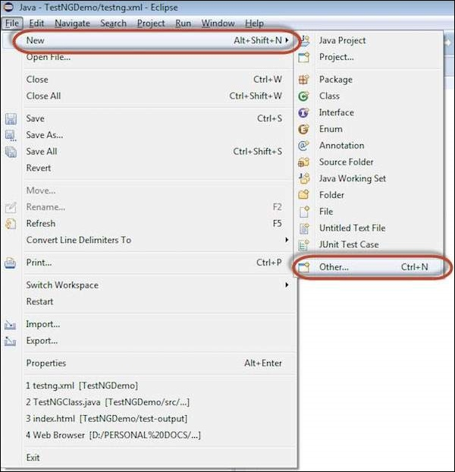

**Step 3** − Select 'File' from 'General' and click 'Next'.

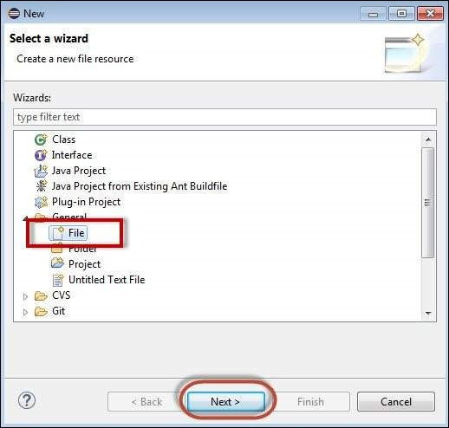

**Step 4** − Enter the name of the file and click 'Finish'.

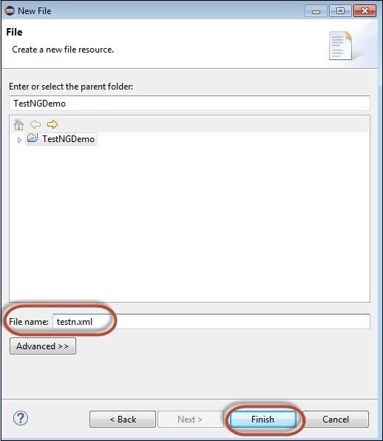

**Step 5** − TestNg.XML is created under the project folder as shown below.

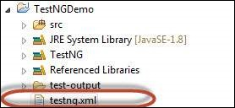

**Step 6** − The contents of the XML file are shown below. We create 3 tests and put them in a suite and mention parallel="tests" so that all the tests would be executed in parallel.

<?xml version = "1.0" encoding = "UTF-8"?>

<!DOCTYPE suite SYSTEM "http://testng.org/testng-1.0.dtd">

<suite name = "Suite" parallel = "tests">

<test name = "FirefoxTest">

<parameter name = "browser" value = "firefox" />

<classes>

<class name = "TestNG.TestNGClass" />

</classes>

</test>

<test name = "ChromeTest">

<parameter name = "browser" value = "chrome" />

<classes>

<class name = "TestNG.TestNGClass" />

</classes>

</test>

<test name = "IETest">

<parameter name = "browser" value = "ie" />

<classes>

<class name = "TestNG.TestNGClass" />

</classes>

</test>

</suite>

Test Execution

**Step 1** − Select the created XML; right-click and choose 'Run As' >> 'TestNG Suite'.

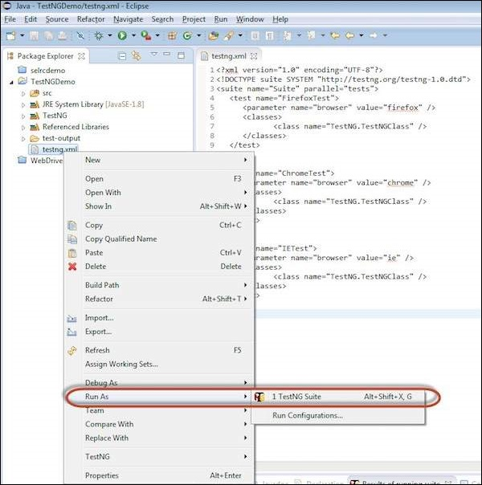

**Step 2** − Now open the Node, where we have launched all the browser nodes. You will see all the three browsers in execution simultaneously.

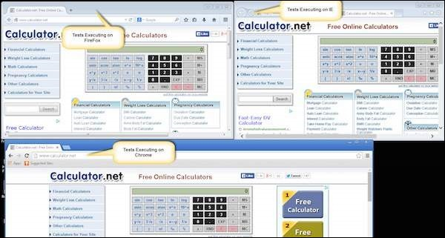

Result Analysis

**Step 1** − Upon completing the execution, we can analyze the result like any other execution. The result summary is printed in the console as shown in the following snapshot.

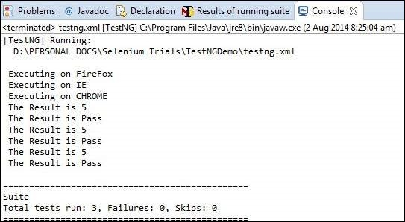

**Step 2** − Navigate to the 'Results of Running Suite' Tab and TestNG would display the result summary as shown below.

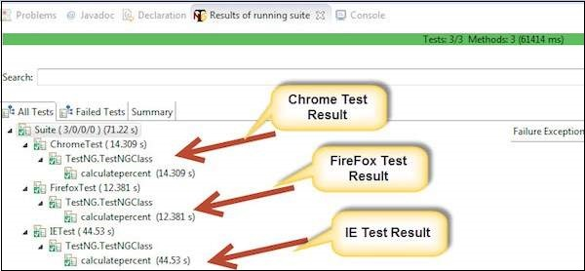

**Step 3** − Upon generating the HTML, we will be able to see the test results in HTML format.

